Experiences and lessons managing water in Cape Town with the advent of ‘Day Zero’
Robbie Parks, Megan McLaren, Ralf Toumi, Ulrike Rivett
Outline
- Introduction (IMPERIAL)
- ‘Water is a natural resource that is embedded in the cultural and religious values of societies. It is what we take pictures or create paintings of. It is why we construct fountains.’¹
- Hydrological drought is associated with precipitation shortage on a longer time scale (12 months to 2 years or more).
  - The challenge of water management and drought globally
    - Importance of good water management
- Demand for water is growing, both due to population increases, changing diets, as well as changes in the way people aspire to use water.
- ‘There are many regions where our freshwater resources are inadequate to meet domestic, economic development and environmental needs’¹
- ‘In recent decades the percentage increase in water use on a global scale has exceeded twice that of population growth’¹
- ‘1 of every 6 units of water treated across the United States never reaches the consumer.’²
    - Globalization of water
- ‘Virtual water’ is the water used in production of a commodity (e.g. food), produced locally to then be exported around the world. This affects local real water supplies.³
    - Changing supply and demand patterns due to climate change
    - Growing urban demand
- ‘Urban water demand will increase by 80% by 2050, while climate change will alter the timing and distribution of water’.⁴
- More than 27% of cities studied, containing 233 million people, will have water demands that exceed surface-water availability⁴
    - Freshwater stress
- ‘Adaptation to global change must include prudent management of groundwater as a renewable, but slow-feedback resource in most cases. Groundwater storage is already over-tapped in many regions, yet available subsurface storage may be a key to meeting the combined demands of agriculture, industry, municipal and domestic water supply…’⁵
- ‘The highest vulnerabilities are found at the North African rim of the Mediterranean Sea, in southwestern Africa, in northeastern Brazil and in the central Andes, which are areas of moderate to high sensitivity.’⁶
- ‘Groundwater—the world’s largest freshwater resource—is critically important for irrigated agriculture and hence for global food security’.⁷
    - Monitoring use/new technologies
- Give a brief taste of where it’s going in section 3…
  - Overview of water and drought in Cape Town and South Africa
- High drought frequency but relatively low intensity.⁸
- ‘Drought is a regular feature of the South African climate’.⁹
- Studies of the normalised vegetation index dataset (Los et al., 1994) show that the impact of droughts on vegetation (Farrar et al., 1994) is particularly strong where annual rainfall amount varies from 300 to 500 mm (Richard and Poccard, 1998). This is the case for most of South Africa.⁹
- Fig:2 Global urban water security (n=482).⁴
  - Usefulness of Cape Town as an example of an industrialised city in a semi-developing country
- Overview of sustainable development goals:¹⁰
      - 6: Clean water and sanitation
      - 11: Sustainable cities and communities
      - 12: Responsible consumption and production
- Statistical comparison:¹¹ (to London/NYC/Sydney/Tokyo/Berlin/Paris etc.)
      - GDP per capita: R76 420 (£4,307)
      - GDP annual growth rate ~3.7% a year
      - Main industries: Finance and insurance largest contributor to growth rate
      - Urbanisation: rapid urban growth (statistic?)
      - Population: 4,131,729 by 2020
      - South Africa is one of the most inequitable countries in the world, with a 2014 Gini coefficient of 0.64. South Africa is slightly lower at 0.62 (comparison of UK/London/NYC/Tokyo etc.)

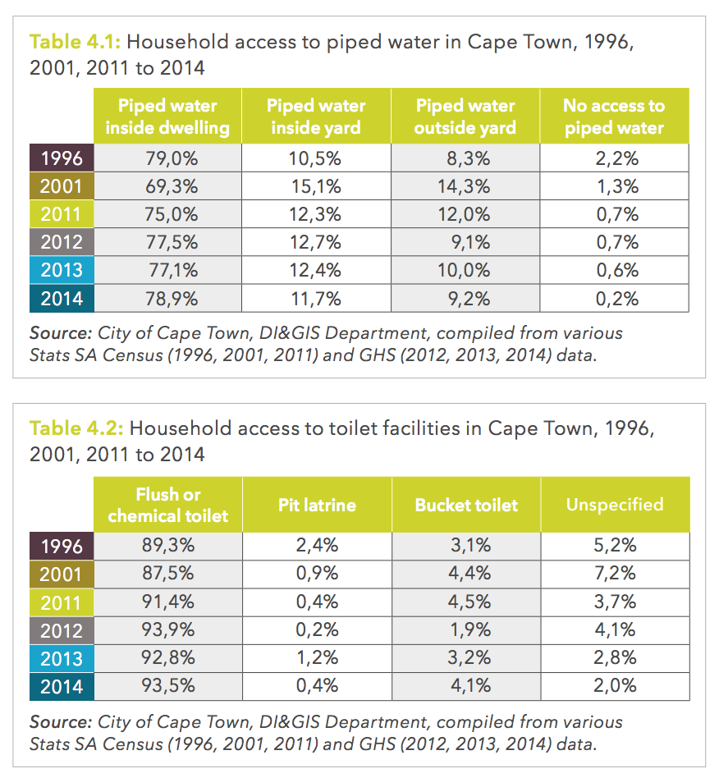

- Comparison of water footprints of Cape Town and other industrialised cities¹²¹³
  - Water guarantee in the South African constitution
- ‘Section 27: the rights to food, water, health care and social assistance, which the state must progressively realise within the limits of its resources’.
  - Main supplies and uses of water in South Africa and Cape Town
    - Governance of water supplies
- Clash between political parties and local and national governance. Political squabbling.
- Declaring a particular drought as a disaster having political and management consequences.
    - Overview of surface water
    - Rainfall in South
- Strong inter-annual variability rainfall variability since 1970.⁹
- Average rainfall in Cape Town⁹
    - Uses of water in South Africa and Cape Town
- South Africa stats below:
      - Explanation of blue/green/grey water: http://waterfootprint.org/en/water-footprint/what-is-water-footprint/
      - https://businesstech.co.za/news/general/104441/who-is-using-all-the-water-in-south-africa/

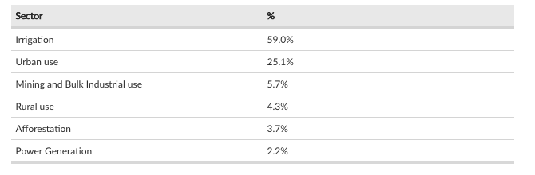

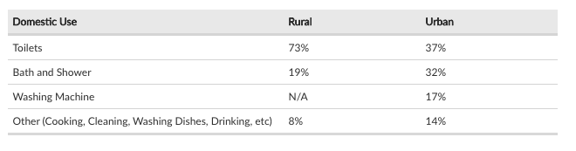


- Cape Town stats below:
  - Formal housing compared with informal settlements
  - Much much less water in informal settlements, although the vast majority of population.
  - While most people are living from taps, richest section using most do not actually do this and so are the ones experiencing rationing for the first time
- Why is Cape Town experiencing drought? (IMPERIAL)
  - What is ‘Day Zero’?
- Dam levels falling below 13.5% of total capacity
  - Weather and climate context
  - Overview of Cape Town’s seasonal water cycle and supply
- https://citymaps.capetown.gov.za/waterviewer/

- 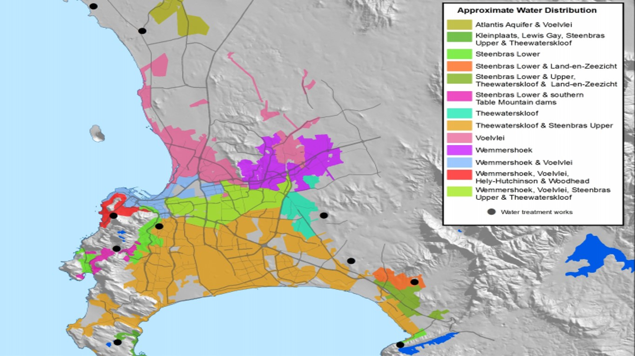

(http://www.thewatershedproject.co.za/wp-content/uploads/2015/05/Where-does-my-water-come-from-1.jpg)
  - Threats to water supply under climate change

- How did the possibility of drought impact Cape Town? (IMPERIAL/UCT)
  - Management and rationing of water
  - Social and behavioural impacts
  - Health impacts
  - Economic impacts
  - Differential of impacts on different strata of society (rich/poor/black/white)

- How is Cape Town adapting to its new reality? (UCT)
  - Early Warning Systems of drought
  - Water proliferation technology, what works and what doesn’t
  - Monitoring water use
  - Increasing transparency of existing water usage data
  - Political ramifications of drought

- Policy recommendations (IMPERIAL/UCT)
  - Lessons learnt
    - Importance of political harmonisation of drought
  - What works and what doesn’t
  - Technological recommendations
  - Social policy recommendations
  - How to engender long-lasting behavioural change
  - Relevance to other places in the world

Bibliography
1 Cosgrove WJ, Loucks DP. Water management: Current and future challenges and research directions. Water Resour. Res. 2015; 51: 4823–39.
2 Chini CM, Stillwell AS. The State of U.S. Urban Water: Data and the Energy-Water Nexus. Water Resour. Res. 2018. DOI:10.1002/2017WR022265.
3 Hoekstra AY, Hung PQ. Globalisation of water resources: International virtual water flows in relation to crop trade. Glob Environ Chang 2005; 15: 45–56.
4 Flörke M, Schneider C, McDonald RI. Water competition between cities and agriculture driven by climate change and urban growth. Nat Sustain 2018; 1: 51–8.
5 Green TR, Taniguchi M, Kooi H, et al. Beneath the surface of global change: Impacts of climate change on groundwater. J. Hydrol. 2011; 405: 532–60.
6 Doell P. Vulnerability to the impact of climate change on renewable groundwater resources: A global-scale assessment. Environ Res Lett 2009; 4. DOI:10.1088/1748-9326/4/3/035006.
7 Aeschbach-Hertig W, Gleeson T. Regional strategies for the accelerating global problem of groundwater depletion. Nat. Geosci. 2012; 5: 853–61.
8 Spinoni J, Naumann G, Carrao H, Barbosa P, Vogt J. World drought frequency, duration, and severity for 1951-2010. Int J Climatol 2014; 34: 2792–804.
9 Rouault M, Richard Y. Intensity and spatial extension of drought in South Africa at different time scales. Water SA 2003; 29: 489–500.
10 Griggs D, Stafford-Smith M, Gaffney O, et al. Sustainable development goals for people and planet. Nature 2013; 495: 305–7.
11 City of Cape Town. State of Cape Town Report 2016. 2016; : 79.
12 Hoekstra AY, Chapagain AK. Water footprints of nations: Water use by people as a function of their consumption pattern. In: Integrated Assessment of Water Resources and Global Change: A North-South Analysis. 2007: 35–48.
13 Hoff H, Döll P, Fader M, Gerten D, Hauser S, Siebert S. Water footprints of cities - Indicators for sustainable consumption and production. Hydrol Earth Syst Sci 2014; 18: 213–26.

